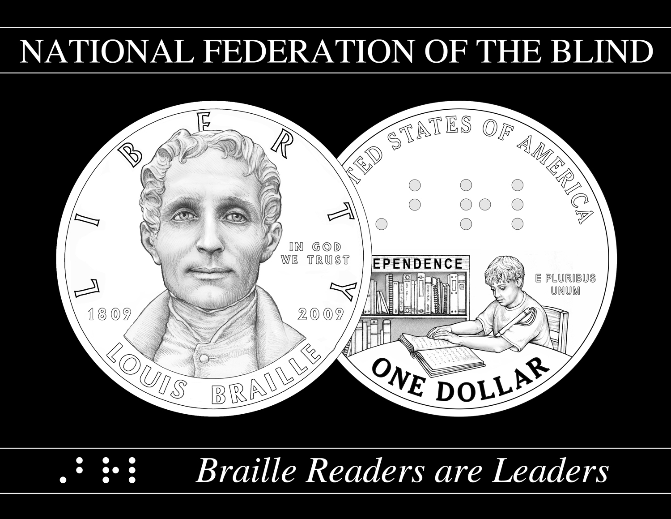
Braille Readers are Leaders

FUNDRAISING AND
AWARENESS IDEAS

The U.S. Mint Commemorative Coin can generate substantial funds for Braille literacy programs. The National Federation of the Blind will receive a $10 surcharge on every one of the coins sold during 2009. With four hundred thousand coins being minted, that could reach $4 million. NFB must also raise $4 million in matching funds, so the entire campaign could generate $8 million in one year. Any coins unsold by December 31, 2009, will be destroyed. So, there are two priorities:
- Raise funds for NFB Braille literacy programs, using the Commemorative Coin and the need for matching funds as motivation.
- Sell Commemorative Coins.

Note: NFB receives only $10 per coin sold, but it receives 100 percent of the funds raised in support of the Braille literacy campaign. Fundraising around the coin is more important than coin selling.

Also, the Commemorative Coin will be launched in Spring 2009, and NFB cannot accept pre-sales for the coin. However, the www.braille.org Web site is ready to collect contact information so individuals will be informed when they can purchase coins from the U.S. Mint Web site.

NFB will develop a series of videos around the “Braille Readers are Leaders” campaign to support your public awareness, fundraising, and Braille literacy education efforts. As soon as they are available, you will receive copies.

Concerning fundraising–first, some facts:
- 81 percent of all income for nonprofit organizations comes from individual donors, as opposed to 7% from foundations and 6% from corporations.
- 85 percent of all individual donations come from families with incomes of $50,000 or less. Nineteen percent of people on welfare contribute an average of $72 per year.
- People give when they are asked, and rarely give when they are not.
- Face-to-face–sitting down with a person (preferably a person you know) and asking for a gift to an organization you support is the most effective way to raise money. It’s also the most stressful, uncomfortable, and labor-intensive way as well. Still, around 50% of the people that you ask face-to-face will say yes to your request.
- Personal phone call–if a person lives too far away to ask personally or is too busy to meet with you face to face, you can expect around 15 to 20% of the people you ask by phone to say yes to your request.
- Personal letters are a low-key way to ask friends and colleagues for gifts, but it’s less effective than talking with them in person–expect a 10% yes.
- The cardinal rule of fundraising is–money is attracted to passion. Your excitement and commitment to the cause is the most effective magnet for fundraising support. People will support someone who cares deeply about something important.
- Donors are not ATMs. You need to thank them and keep them posted on what your organization is doing with their money.

A good fundraiser requires three character traits:
- A belief in the cause for which you are raising money and the ability to maintain that belief during defeats, tedious tasks and financial insecurity.
- The ability to have high hopes and low expectations, allowing you to be often pleased but rarely disappointed.
- Faith in the basic goodness of people.

Go through your contact list–Who do YOU know? Who do THEY know? The “six degrees of separation” idea is that, if a person is one step away from each person he or she knows and two steps away from each person who is known by one of the people he or she knows, then everyone is an average of six “steps” away from each person on Earth. You just need to find the right six people to make the right connection to reach anyone.
NFB is building a list of “Braille Ambassadors”–nationally known celebrities and individuals who could be spokespersons, lend their names, help us open doors–and an Advisory Board of corporate and foundation executives with a national profile who can contribute and reach out to their peers to support the Braille Readers are Leaders campaign.
So, who would be on your target list?
- Celebrity spokespersons? Who do you know? How can you reach them?
- Corporate executives from the following industries (for brainstorming purposes):
    - Automotive
    - Banks and financial companies
    - Broadcast and print media
    - Clothing manufacturers
    - Computers
    - Food manufacturers and grocery chains
    - Pharmaceuticals
    - Sports
    - Travel
    - What others?

Make a personal goal of how much you will raise for the Braille Readers are Leaders literacy campaign. Write down that goal and revisit it every day until you reach it.
Here are a few suggestions for communicating about the Braille Readers are Leaders literacy campaign and the Commemorative Coin that you can activate in your own community:

- Write stories for your affiliate Web site, with a link to www.braille.org.
- Send e-mails to your members, directing them to go to www.braille.org to register to receive information about the Commemorative Coin.
- Distribute the Commemorative Coin flyers from the U.S. Mint.
- Set up speaking engagements at local organizations, such as Lions Clubs, Rotary, Chamber of Commerce, civic clubs, schools, churches, reading clubs, youth groups, libraries, etc.
- Set up tables at fairs, community events, and local sports events.
- Host “coffees” or a house party to introduce the Braille literacy campaign and Commemorative Coin. Do not charge admission, and invite as many people as you can. During the party, give a short talk, explaining why this is important to you, and ask everyone to consider a gift of $25, $50, $100 or more (depending on the crowd). Either pass out envelopes and ask people to give then, or after the party contact everyone individually who came and ask for a major gift.
- Distribute flyers to retail stores, banks, etc.
- Ask your church to do a “second collection” after you or someone from your congregation gives a brief talk (or sometimes the whole sermon) about Braille literacy.
- Set up tables outside Wal-Marts, grocery stores.
- Visit with local newspaper reporters and editors to let them know about the Commemorative Coin and the Braille literacy campaign.
- Start a blog and make Braille literacy one of your topics.
- Find out which of your friends work in corporations with matching gift programs, then ask them (and ask them to ask their co-workers) to donate and get their gift matched by their company.
- Visit senior groups and talk about Braille as a tool for low vision seniors.
- With four or five friends, have a spaghetti dinner at a temple, church, or union hall or other big room with a large kitchen. Charge $10 per person and feed more than one hundred people. You can charge extra for wine or garlic bread, or for dessert.
- Talk to school administrators and teachers to promote the “Braille Is Beautiful” curriculum, especially during Meet the Blind Month (October).
- Investigate how much Braille is in the school and public libraries in your area. Start a “Buy a Book for a Kid” campaign, emphasizing that all children should be able to access what they need in the school public libraries.
- Invite people to your birthday party and ask that in lieu of gifts, they give money to the campaign.
- Ask five to ten friends to join you in saving all their change for three to five months.
- Offer to do something that your friends and family have been nagging you to do anyway and attach a price to it. For example, quit smoking on the condition that your friends donate to the campaign, or get your friends to pay a certain amount for every day you don’t smoke for up to thirty days. This could apply to exercising, not eating sugar, shaving off a beard, etc.
- Work with regional Barnes & Noble, Borders and other bookstores, as well as public libraries, to have Braille reading events of children’s books. Set up a Braille display during January to celebrate Louis Braille’s 200th birthday.
- Produce the play “The Eloquence of Courage” by Jerry Whittle, a teacher at the Louisiana Center for the Blind. It is a short drama, portraying how Louis Braille overcame obstacles to keep his reading and writing code alive. The script is available from NFB in Braille or print.
- Get a bond or other appropriations bill passed through your state legislature to provide a matching grant to fund your state’s contribution to the Braille Readers are Leaders literacy program. If every state contributed $100,000, we could raise $5 million from that source alone. Make sure your state gets on the growing list of contributing states. Attached is sample legislation
- Do a phantom event. Invite people not to come to something, but send a check instead. “You will not have to get dressed up or find parking. You will not have to balance a plate of raw vegetables and dip and a drink while trying to shake hands with people you don’t know.” Keep it fun and humorous. The reply card should say “I won’t be there. I am so looking forward to that! Here’s my gift. Thanks for letting me stay home.”

What else? Your only limitation is your imagination.

