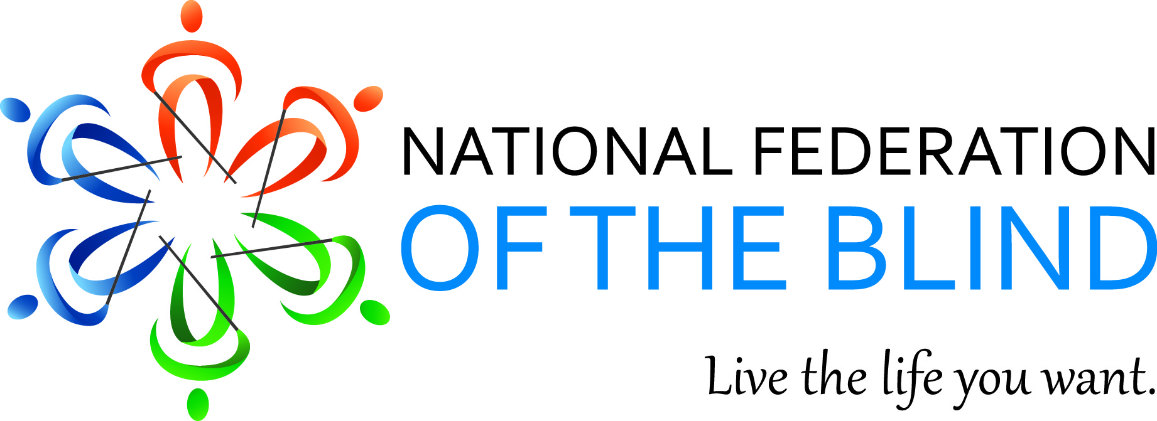

National Federation of the Blind Jernigan Institute

Voting Guide for Young People who are Blind or Visually Impaired

Why Vote?

The right of blind Americans to vote is guaranteed by the United States Constitution. It is a right that many American citizens have demonstrated, fought, and died for so that present and future generations can continue to exercise their right to vote. Therefore, every blind or visually impaired citizen who is of voting age has a responsibility to exercise the right to vote.

Voting in any election, local or national, provides blind and visually impaired citizens with the opportunity to voice their opinion about elected leaders and policies, and to help shape the future by electing candidates who share their views. Elected officials make decisions and pass legislation that impact how Braille is taught in the classroom, the accessibility of technology used in an educational setting, and funding of rehabilitation training. Consequently, voting for candidates who share their views on these issues is one of the most effective ways that blind and visually impaired young people who are eligible to vote can influence policy and legislation addressing these issues.

When a citizen does not vote, she is giving away her right to influence our government and, as a result, government by the will of the majority is replaced with government by the will of the minority. During the presidential elections of 2008 and 2012, a bare majority of 58 percent and 55 percent, respectively, of voting age Americans cast ballots. However, during the midterm elections of 2010 and 2014, only 41 percent and 36 percent, respectively, of the voting age population voted.

A significant factor in the low voter turnout that has been experienced during elections in the United States is the very low turnout among voters aged eighteen to twenty-four. Only forty-four percent of voters in that age group voted in the presidential election of 2008, and the percentage dropped even lower to forty-one percent in 2012. For the midterm elections in 2010 and 2014, the percentage of eighteen to twenty-four year olds who voted was only twenty-three percent and twenty-one percent, respectively. It is vital that blind and visually impaired Americans of voting age exercise their right to vote so that government by the will of the majority is assured.

Your Right to Vote Privately and Independently

Prior to the passage of the Help America Vote Act (HAVA) in 2002, voters who were blind or visually impaired had to rely on sighted assistance to mark their ballot. HAVA has enabled voters with disabilities to fully exercise the fundamental right to vote privately and independently by requiring that every polling place have at least one accessible voting system for all federal elections. In addition, many states have enacted legislation to require at least one accessible voting system in each polling place for all state and local elections.

Registering to Vote

In order to exercise the right to vote, a blind or visually impaired citizen must first register with their state or district board of elections. To register as a voter, you must:

- be a United States citizen,
- be a resident of the state or district in which you are registering, and
- be at least eighteen years old.

Many states have additional requirements that must also be met.

Registration forms can be obtained from your state, district or local board of elections, libraries, and government offices. In addition, many states provide online voter registration through the Secretary of State's or state board of elections' website. Registering only takes a few minutes, so be sure to exercise your right and responsibility as a citizen by registering to vote, and voting!

How Does a Blind Person Vote?

Blind and visually impaired voters may cast their ballot at their local polling place on Election Day, by voting at an early voting center, or completing an absentee ballot prior to Election Day. Most of the accessible voting systems in use today at the polling place or early voting center utilize a touch screen where voters can view the ballot and make selections. They will also include an audio ballot, as well as large print and other low vision features to enable blind and visually impaired voters to vote privately and independently. These systems are designed to be easy to use, so no need to worry if you are not a techie!

The speech of the audio ballot may be either synthesized or a recorded human voice. Headphones are connected to the voting system so that only the voter can hear the ballot. A control box with buttons or a telephone style keypad is used by the voter to go through the ballot contests and make selections, as well as to increase or decrease the speed and volume of the audio. Instructions at the beginning of the ballot will tell you what buttons to push to move through the ballot and make selections. Voters with low vision can enlarge the print displayed on the touch screen and change the contrast to make the print easier to read. Voters with low vision make their selections simply by touching the screen.

Another type of accessible voting system in use at polling places today utilizes the telephone. With this system, the poll worker calls a telephone number, enters a code, and then hands the phone to the voter. The voter uses the telephone keypad to move through the audio ballot and make selections.

A number of states have switched from a system based on voting at a local polling place to a vote by mail system. In a vote by mail system, a paper ballot is mailed to the voter, who marks the ballot by hand, and then mails it back to the local board of elections. States who use a vote by mail system must still comply with HAVA and provide an accessible ballot marking system to blind and visually impaired voters for all federal elections.

Before Election Day arrives, it is always a good idea to take an opportunity to practice vote, particularly if you are a first-time or new voter. Invite a representative from your local board of elections to a meeting of your local NFB chapter, or to your school to demonstrate the accessible voting machine and allow voters to practice vote. This way, when Election Day arrives, you will be able to concentrate on making your selections without being distracted by trying to figure out how to operate the voting system.

Another way that blind and visually impaired citizens can vote is with an absentee ballot. In general, state election law permits blind and visually impaired voters to vote in any election by absentee ballot. However, voting by absentee ballot typically involves a paper ballot and telling your choices to a sighted assistant who marks the ballot for you. Consequently, voting by absentee ballot is usually neither a private nor an independent way to vote for many blind and visually impaired voters.

Some states are starting to make online ballot delivery and marking systems available to voters with disabilities. When designed in accordance with the Web Content Accessibility Guidelines (WCAG) 2.0 AA, these systems allow voters with disabilities to access and mark their ballot using their own computer and access technology. Once the ballot has been marked, it typically is printed and mailed to the local board of elections to be counted.

What to Expect at Your Polling Place

If you are voting on Election Day, you will need to go to the polling place for your election district or precinct. The location of your polling place will be indicated on your voter registration card. You may also be able to find your polling place location on the website of your local or state board of elections.

Once you have arrived at your polling place, you will need to check in with poll workers by giving your name and requesting an accessible voting system. If you live in a state that requires some form of photo identification, you will need to show an acceptable form of identification to the poll worker who checks you in. Once you have given your name and shown your identification, be sure to repeat your request to use an accessible voting system. After your check in process is complete, a poll worker will show you where the accessible voting system is located and hand you the headphones and control box. Depending on the type of machine, you may need to insert a paper ballot. Once the audio ballot has started, the poll worker should walk away so you can vote in private.

What to Do When Things go Wrong

Poll workers have many responsibilities on Election Day. In addition, the training they receive on the accessible voting system is frequently insufficient to equip them with the knowledge they need to set up and operate the system, and to resolve any problems that may occur. Consequently, it is not uncommon for blind and low vision voters to encounter poll workers who do not know how to set up or operate the accessible voting system.

If upon your arrival at the polling place for a federal election poll workers tell you that the accessible voting system is not available or not working, or if the system malfunctions while you are voting, it is extremely important that you politely, but firmly, insist on your right to vote privately and independently. Request that an accessible system be brought to the polling place, or that a technician be sent to the polling place to repair the system. If poll workers offer to assist you in marking a paper ballot, politely decline this offer, and firmly, but politely, repeat your desire to vote privately and independently using an accessible system.

In many cases when a voter is patient and politely, but firmly, insists on her right to vote using an accessible system, poll workers are able to resolve the problem. However, if poll workers have made every attempt to honor your request, but are unable to provide an accessible voting system that operates properly, you should still exercise your right to vote by voting with assistance.

If you are unable to vote privately and independently on an accessible voting system at your polling place during a federal election because there is no accessible system available or the system is not operating, the most important thing you can do is to file a HAVA complaint with your state or local board of elections. While HAVA guarantees the right of blind and visually impaired voters to vote privately and independently, it does not provide them a means to enforce this right through private action when it is violated. Therefore, filing a HAVA complaint is the most effective way blind voters can be sure that problems are brought to the attention of election officials and the U.S. Department of Justice, which has authority to enforce HAVA. Because there is no private right of action under HAVA, it is imperative that blind voters who are not able to vote privately and independently at their polling place during a federal election file a HAVA complaint so that the Justice Department has a true picture of the problems that voters with disabilities are experiencing.

Make Your Voice Heard

The United States Constitution guarantees the right of all blind and visually impaired citizens to vote and the exercise of this right is vital to the function of our democratic form of government. With the passage of HAVA, it is now possible for blind and visually impaired citizens to exercise their right to vote both privately and independently. Making your voice heard through voting is imperative because state and federal elected officials implement policies and pass legislation that directly affect our lives as blind or visually impaired people. Make your voice heard - register to vote and exercise your right and responsibility to vote!

