Voting and the Blind: The Experience of Blind Voters During the November 2008 National Elections

Between November 6 and 17, 2008, the National Federation of the Blind Jernigan Institute, utilizing a grant funded by the U.S. Department of Health and Human Services, Administration for Children and Families, conducted a random sample telephone survey of households across America. The purpose of the survey was to determine if blind voters were able to cast their vote privately and independently, as guaranteed by the Help America Vote Act (HAVA), and to assess the experience of blind voters during the November 4, 2008, national election. A total of 994 households were contacted and screened for inclusion in the survey. In 581 of these households there was a member age eighteen or older who cannot read regular print, such as newspapers, at a normal reading distance even with their best corrected vision. From these 581 households, 560 individuals were confirmed to be legally blind and were interviewed.

Summary of Survey Results

Almost all (94%) of the legally blind individuals interviewed in this study said they are registered voters, and nearly all of these registered voters (96%) voted in the November 2008 election. Roughly one-third (38%) of the individuals who voted did so by mail or absentee ballot, while nearly two-thirds (62%) voted at the polls.

Half (51%) of the blind voters who cast their ballot at a polling place did so independent of assistance, while more than a third (39%) relied on the assistance of a family member or friend. Only a tenth (9%) required the assistance of a poll judge, and a few (1%) used a paper ballot and/or magnifying glass.

Just under two-thirds (63%) who cast their vote at the polls said they requested or were offered the use of an accessible voting machine. Most said the voting machine was up and running upon their arrival (87%) and that the poll workers had no problems setting up or activating the machine (81%).

A majority (87%) of voters who cast their vote using an accessible voting machine experienced no problems with the machine. Of the 13% who did encounter problems, the most frequently mentioned issues were that the workers were not trained and did not know how to operate the machine, the machine was not set up, and they could not adjust the audio speed or the audio did not work.

A majority (86%) who used an accessible voting machine were able to cast a secret ballot. The 14% who could not cast a secret ballot most often said the reason was because workers could not operate the machines, there were no working machines available, or they felt more comfortable with assistance.

Blind voters appear to have felt that they were treated well by poll workers, as nearly all felt they were treated with respect (94%), they were treated with the same dignity as other voters (91%), and they were given the same privacy as other voters (85%). In addition, most felt they were not rushed (94%), poll workers did not make them feel like they were a bother (92%), they were not treated like they lacked the capacity to vote (90%), and they were not treated as if they were incapable of voting independently (89%).

How to Improve the Voting Experience

Including those who voted by mail and in person at the polls, 89% were satisfied with their overall experience; so, it is not surprising that a majority (61%) offered no suggested ways to improve the experience. The most frequent suggestions were to make accessible voting machines available (6%), educate or train poll workers (5%), be sure accessible voting machines are set up and working properly (4%), provide larger print or magnification (4%), and make it possible for blind voters to cast an independent and private vote (4%).

Survey participants were also asked if they would be interested in receiving training on the use of accessible voting machines. Those most interested in receiving training were among those who were less than satisfied with their most recent voting experience (72%).

Conclusion

The results of the NFB’s national telephone survey indicate that a majority of eligible blind American voters exercised their right to cast their vote privately and independently, as guaranteed by HAVA, on November 4, 2008. It may also be concluded from our survey data that a majority of states are in compliance with the HAVA requirement that at least one accessible voting machine be available at each polling place for federal elections. While the vast majority of blind voters were satisfied with their voting experience, some voters encountered problems, such as malfunctioning machines and poorly trained poll workers. Thus, it is important for election officials to ensure that poll workers are properly trained in the operation of accessible voting machines and that technical support is available when machines malfunction.

To view the full Blind Voters Experience Assessment Study report, go to http://www.nfb.org/nfb/HAVA_legislation.asp.

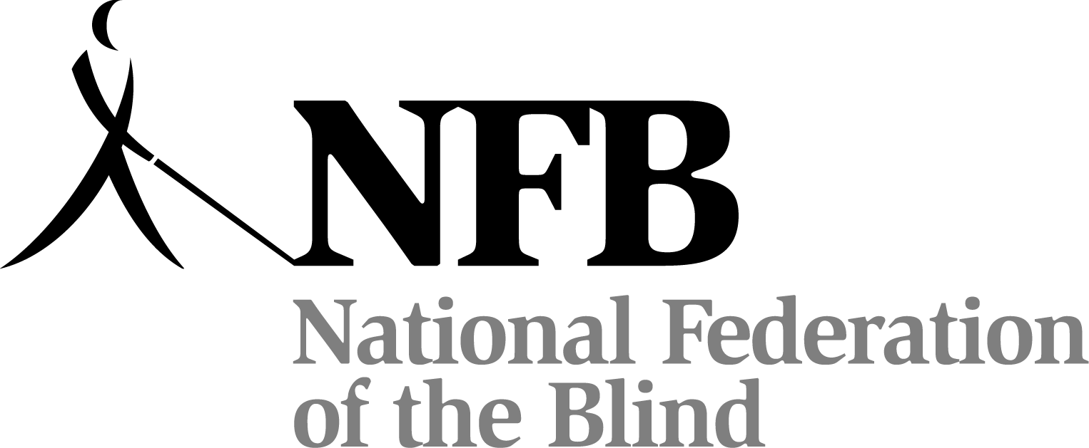

National Federation of the Blind Jernigan Institute
1800 Johnson Street
Baltimore, Maryland 21230
(410) 659-9314
www.nfb.org

