Nonvisual Access Election Technology Guide

Introduction

According to the 2006 National Health Interview Survey, 21.2 million Americans have experienced significant vision loss. Prior to the enactment of the Help America Vote Act (HAVA) on October 29, 2002, many of these Americans were unable to vote privately and independently because they could not read the paper ballots that were in use at that time. With the passage of HAVA, all voting jurisdictions must provide at least one accessible voting machine in each polling place during federal elections.

Nonvisual access, if integrated in the development process at an early stage, presents a chance to reevaluate the consumer group the product is intended for. It is also an opportunity for creativity that serves the community as a whole, not only those who are blind. Past developments indicate that nonvisual design often represents a move forward in all design, increasing the ease of access and simplicity of operation. For example, optical character recognition, pioneered in a reading machine for the blind, has since become mainstream technology in voting and in other areas, as have the type of portable devices that were first used as notetakers by blind people.

With the advent of HAVA, election technology has evolved from mechanical voting machines to the use of electronic touchscreens, vote-by-phone systems, and html pages. These advances offer opportunities as well as pitfalls when it comes to accessibility to blind and low-vision users. The purpose of this guide is to familiarize election technology developers and purchasers of elections systems with the characteristics necessary to make voting systems that are accessible to blind, low-vision, and other print disabled Americans.

Accessibility and Electronic Touchscreen Voting Machines
and Vote-by-Phone Systems

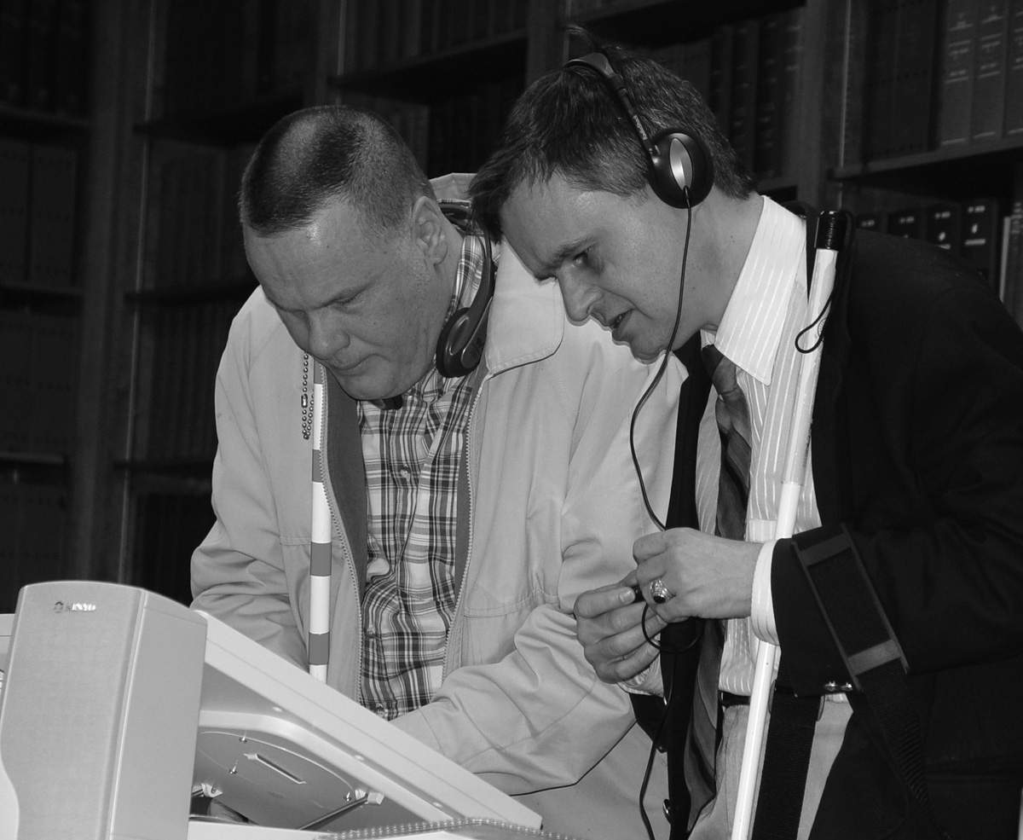
Blind users need a voting system that can be configured for audible voting with as much ease as possible. The voting system should be usable by all voters with minimal or no training needed and should be usable by both blind and sighted voters.

What should happen during the voting process?
As blind voters, we should be able to move freely from contest to contest and not be required to listen to all the instructions and text. However, all the text of each contest must be present and readable if we choose to listen to it. The visual appearance of the ballot does not have to be reflected in the audio presentation, as long as all the information is presented audibly.
At the beginning of the ballot, voters should be informed of the total number of contests. Each contest should be described as it is presented. As contests are selected, the total number of candidates and the maximum number of candidates to vote for must be announced. As candidates are selected, the total number selected should be announced. A voter should have the ability to decide to cast votes, skip to another contest, or “under vote” the contest.
Voters must be able to cast their votes at any time. A review function must be available, and the voter must have the opportunity to decide whether to listen to the review or cast their vote immediately. During the review process, it should be possible to move freely between contests and to have the chance to change a previous selection. In addition, blind voters should retain the possibility of obtaining the assistance of a sighted reader at any time during the voting process.
If no user input is provided to the voting terminal for more than twenty seconds, an instruction should be given regarding the choice to be made. The system should not move on to another selection or action until an item is completed. If a voter does not take any action for several minutes, the machine should indicate that the voting process is about to terminate with no ballot cast. This protects against someone else voting in place of the present voter.
Usability checklist for voting machines

The following criteria are preferred by a cross section of potential blind voters.
- Voting systems should be easy to use by both blind and sighted voters and poll workers.
- The interface should not require the use of a technical expert, and it should be easy to learn at the polling location.
- The speech must either be high-quality synthetic speech or a high-quality digital recording of human speech. Care should be taken by the manufacturer and the voting district to ensure proper pronunciation of candidates' names and information unique to local areas.
- Touchscreen voting machines should be able to display text on the screen, providing touchscreen and audio voting at the same time or set to provide visual only or audio only voting. The voter should be able to make these choices on the machine. Large high-contrast print and the ability to reverse colors, such as white letters on a black background, should be selectable.
- The volume of the voting system, and speed and pitch of the voice must be adjustable by the voter. Recordings should be made so that there are no fluctuations in volume among the various steps of the voting process.
- Standard computer keyboards are acceptable. High-contrast color should be used for voters with low vision. A beep or click should be audible to verify that a key has been pressed. If using the arrow keys, include a selection key. The vote key for casting a ballot should be separate from the other keys or its function should be clearly identified.
- For write-in votes, each letter must be selectable by confirming with the select key. There should be a spelling option to review letters entered. The spell function should pronounce the word after it has been spelled. Spaces denote the end and beginning of words. Instructions for selecting letters and completing the write-in selection must be clear and available during the write-in process.
- A help function should be available throughout the voting process. A separate key should be used to request help, and the help should be contextual, with specific help provided depending on where in the process the voter is when requesting help.
- For voting systems providing printed receipts, a review of the receipt should be read after casting the ballot. It should be similar to what is spoken during the voting process, indicating all votes cast and any contests not voted. When an optical scanning system is in use, voters should have the chance to hear what has been printed and then place their ballots in the box with the other ballots for that polling place.
- Instructions must be concise and provide a complete list of the keys and their functions. Voters should be able to move from the instructions to the ballot at any time without having to listen to all the details.
- For touchscreen machines, headphones must be available on site or voters should be able to use their own. Standard headphones may be used. A standard 1/8-inch stereo mini jack should be provided so that audio is heard in both ears.
Accessibility and Web-Based Electronic Voting Systems

Background

The Help America Vote Act (HAVA) sets forth requirements dictating that all polling locations have, during federal elections, voting terminals accessible to users with disabilities. As the definition of “polling place” expands, and as some manufacturers are developing Internet-based vote-anywhere systems, it is important to provide guidance to manufacturers to ensure that these systems are as accessible as their stand-alone hardware counterparts.

Web Content and Accessibility Guidelines (WCAG)

The World Wide Web Consortium has developed a set of standards that should be followed to ensure that Web sites and Web-based applications are accessible to users with disabilities. These guidelines provide developers with the information necessary to ensure that graphics, tables, form controls, color contrast, interactive components, page structure and navigation, and other elements are properly designed to enable all users to successfully transact their business with the site or application. While it is recommended that all WCAG Level AA guidelines be followed, the following sections address the most critical access barriers that are likely to be encountered with voting systems and suggest the types of solutions to ensure the behavior blind users will expect.

Graphics. All active graphics, those providing information or anticipating user interaction, require an alternative text description (ALT attribute). This attribute is a description of the image’s contents, or an indication of the destination/function that will be reached/carried out if the user activates the graphic. Images used for spacing or decoration should have their ALT attribute set to a null value, ALT=””, since speaking text for this type of image can hinder efficient movement through the page. Without properly identified graphics, a blind user is greeted with only the file’s filename, or in some cases, a URL which often will not provide any clue to what the purpose of the
image is.

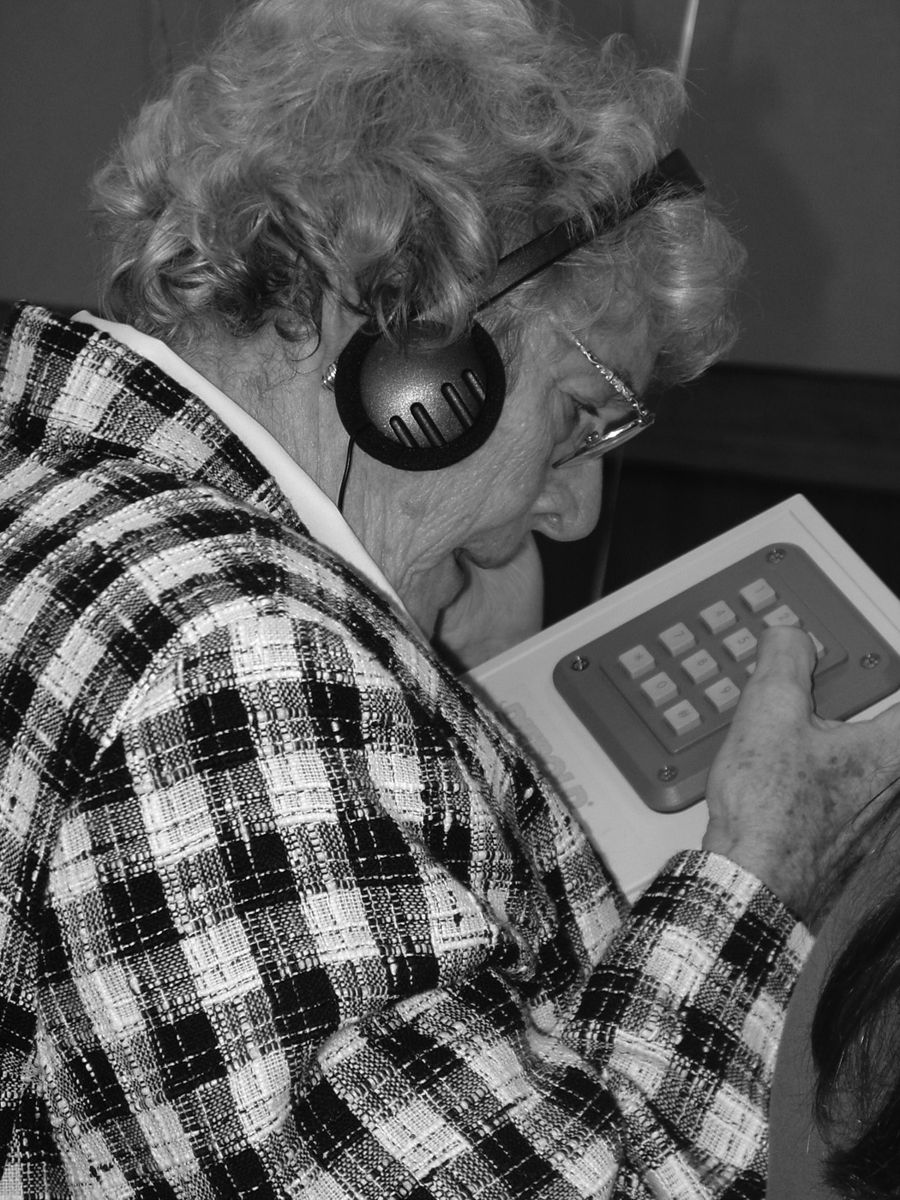
Table Markup. Where tables are used to display data, effort must be taken to determine how a person is intended to utilize the data, and provide the correct markup to allow screen access software to provide blind users with the ability to move through the table to obtain the information they are seeking. This means correctly identifying which cells should be treated as row and column headers and correctly nesting multiple leveled headers. When making this determination the question, “what information, in addition to the currently focused cell, do I need to understand the data in the currently focused cell?” must be answered. In some cases, it may be necessary to indicate more than one column as a row header (for example, if a party name and a candidate name are displayed in separate columns). Tables should not be used to perform page layout or element positioning functions, which is more appropriately done through Cascading Stylesheets (CSS).

Form control Labels. Every form control should be properly labeled to provide screen access software the ability to indicate what information is being sought, or what question and answers are available to users. This means, edit fields, combo boxes, checkboxes, and radio buttons should have the HTML LABEL tag correctly used and the label should be meaningful. It is critical to ensure that indication of required fields be presented in a manner that does not require the ability to perceive color, by use of the asterisk (*) or similar character. This character must be included in the label tag. It is also important to ensure that supplemental information (such as desired format of date input) be included in the label as well. Often times, this information is visually displayed after, or under, the edit field, and not presented to screen access software users. Care should be taken to ensure that all necessary information is included in label tags for radio buttons and checkboxes as well, such as a candidate’s party affiliation.

Radio Buttons, Checkboxes, and Grouped Controls. In cases where it is necessary to convey a contextual relationship between labeled controls and a “parent question” the HTML FIELDSET and LEGEND tag pair should be utilized to convey this information. For example, if a user is being asked who she would like to vote for for president, and a set of radio buttons is used to lay out the form, if she only hears the candidate’s name, and not the option “president”, “select your choice for president”, or similar text, she will be at a disadvantage and unable to cast a fully informed ballot. In addition to radio buttons and checkboxes, edit fields presented in a logical group, for example, “Enter your address” followed by the fields “street”, “City” etc., should include the fieldset to provide logical context.

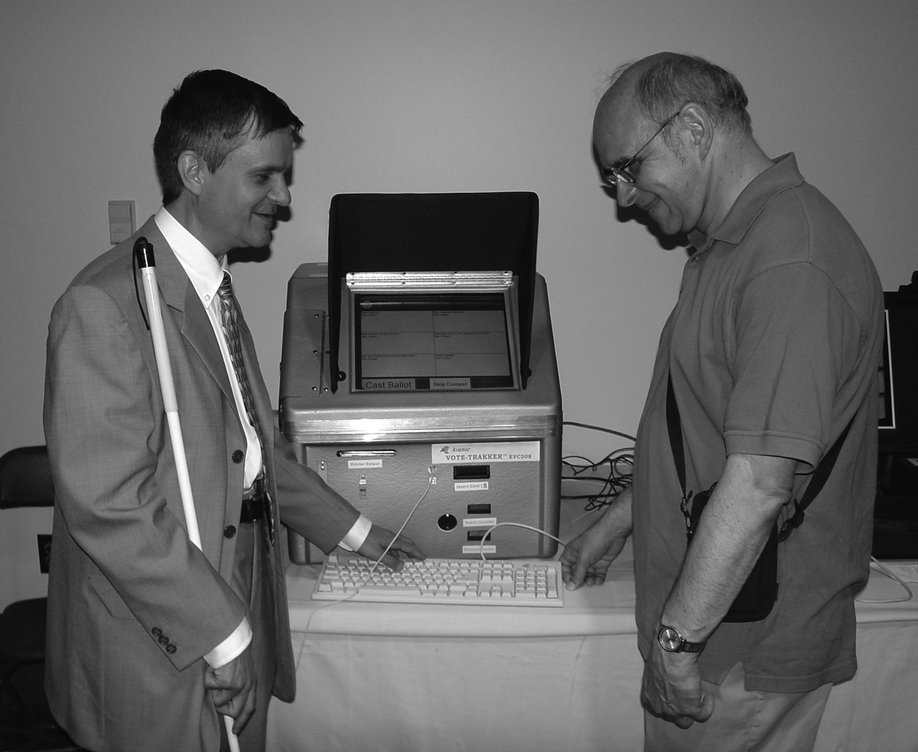
Keyboard Accessible. All controls on a page should be keyboard accessible. Text that is “clickable” should be enclosed in an HTML anchor tag, even if the underlying functionality is controlled by JavaScript, to ensure that a blind user is aware that the text can be “clicked”. Where a tab order is used to control user navigation, all controls necessary to carry out a function should be included in this order. A form with embedded links must have those links included in the tab order or the blind user runs the risk of not knowing they are present.

Headings. HTML headings should be utilized to organize Web pages and allow blind users to navigate through content. There are six levels of headings available to Web developers. These levels are intended to be used like an outline, with each page having a level one heading to indicate the start of the page’s primary content. Subsequent headings should be “nested” with the next major section becoming a level two heading, any subsections a level three, etc. Heading levels should not be skipped. Heading levels should not be used to achieve a desired visual effect, rather this is a job for CSS classes.

The preceding is a brief overview of the critical issues encountered by blind users when navigating Web sites and Web applications. However, following these simple guidelines will provide a solid accessibility foundation for your web-based voting system. For more information or to see the entire list of W3C guidelines, please visit http://www.w3.org/wai.


200 East Wells Street
at Jernigan Place
Baltimore, MD 21230
(410) 659-9314
www.nfb.org

