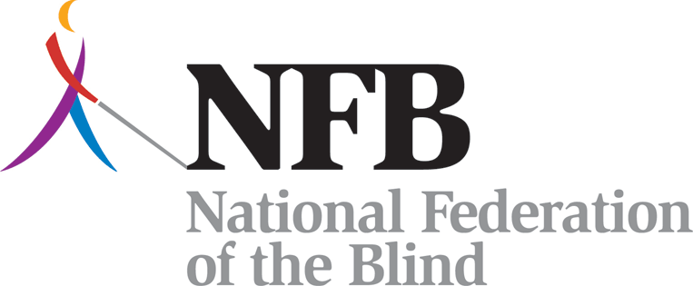
Meet the Blind Month Text Donations

"Send a text message to 41444. In the body of the text, include your team name followed by your donation amount and name, and hit send. You will receive a reply message with a link to fulfill your pledge. If you don’t fulfill your pledge using the link provided, you will receive a follow-up phone call."

Example:
To: 41444
[MD $100 Ilana Posner]

Donations are collected for the benefit of the National Federation of the Blind by the Mobile Giving Foundation and subject to the terms found at www.hmgf.org/t. Messaging and data rates may apply. You can unsubscribe at any time by replying STOP to short code 41444; reply HELP to 41444 for help.

