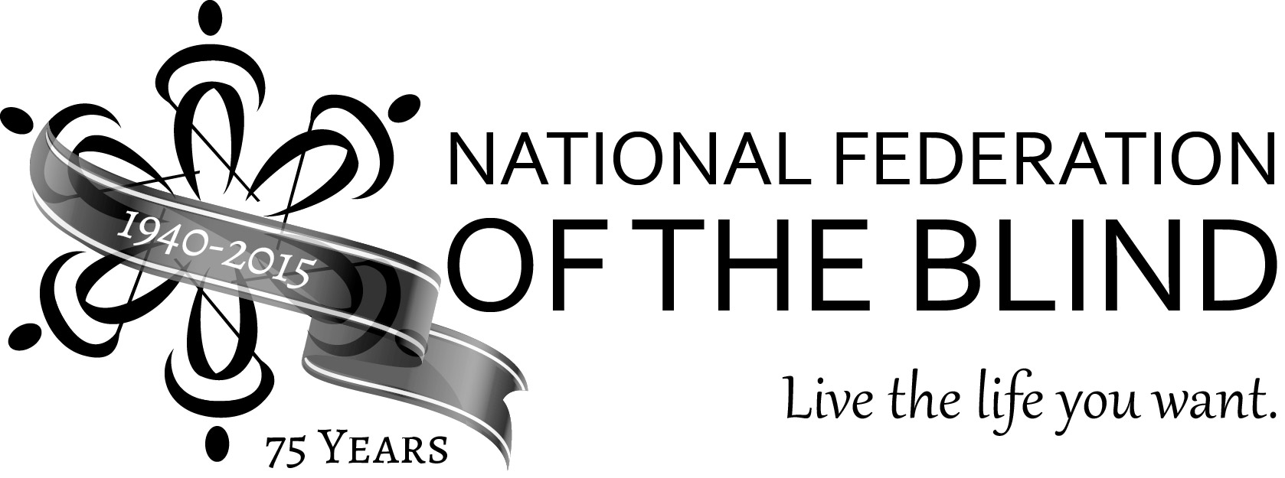
The National Federation of the Blind
And
Sorella Jewelry Studio
Present
The NFB 75th Anniversary Jewelry Collection

Commemorate the National Federation of the Blind’s 75th anniversary with style! Treat yourself or a loved one to elegant, handcrafted jewelry which celebrates our diamond anniversary. Pendants, charms, rings, and cufflinks are available in various precious metals, including sterling silver; 10K white and yellow gold; 14K rose, white, and yellow gold; 18K rose, white, and yellow gold; and palladium. Each piece is cast in the solid metal of your choice and the recessed background matte finish contrasts beautifully with the high polished raised surface.

The jewelry features our logo icon and “NFB 75” in tactual Braille. The NFB Logo features a symbol, which represents Our Movement. It is composed of six icons arranged in a circle and facing each other. The individual icon, which symbolizes Opportunity, suggests a forward-facing view of a stylized figure walking with a long white cane. The pendant features the symbol with the six icons, while the charm, the ring, and the cufflinks show a single icon. The size of the tactual Braille varies, depending on the jewelry type.

Don’t let the 75th anniversary of the founding of the NFB slip by without purchasing one of these precious diamond anniversary mementos. It will bring you joy for years to come.

Charm:
Cast in the solid precious metal of your choice, the 16 mm (just over ⅔inch) round charm features the single NFB icon on the front and “NFB 75” in tactual Braille on the back. The highly polished raised icon, the rim, and the Braille dots contrast beautifully with the matte finish background.
•Sterling Silver: $90
•10K gold (white or yellow): $250
•14K gold (white, yellow, or rose): $315
•18K gold (white, yellow, or rose): $380
•Palladium: $375

Pendant:
Cast in the solid precious metal of your choice, the 20 mm (just over ¾ inch) round pendant features the six icon NFB symbol on the front and “NFB 75” in tactual Braille on the back. The highly polished raised symbol, the rim, and the Braille dots contrast beautifully with the matte finish background.
•Sterling Silver: $160
•10K gold (white or yellow): $315
•14K gold (white, yellow, or rose): $405
•18K gold (white, yellow, or rose): $570
•Palladium: $475

Ring:
Cast in the solid precious metal of your choice, the 8 mm wide band is available in sizes from 4 to 18 in whole and half sizes. (Quarter sizes are available upon request.) The single NFB icon and “NFB 75” in tactual Braille repeat around the band. The number of repeats is determined by the ring size. The highly polished raised edges, icons, and the Braille dots contrast beautifully with the matte finish background.
•Sterling Silver: $340*
•10K gold (white or yellow): $745*
•14K gold (white, yellow, or rose): $925*
•18K gold (white, yellow, or rose): $1,115*
•Palladium: $1,100*

* Ring Size 10 to 11.75, add $45; size 11.75 and higher, add $55

Cufflinks:
Cast in the solid precious metal of your choice, the round cufflinks are 20 mm (just over ¾ inch) in diameter. One cufflink features the single NFB icon, while the other cufflink shows “NFB 75” in tactual Braille. The highly polished raised icon, the rims, and the Braille dots contrast beautifully with the matte finish background.
•Sterling Silver: $295
•10K gold (white or yellow): $745
•14K gold (white, yellow, or rose): $925
•18K gold (white, yellow, or rose): $1,255
•Palladium: $1,150

How to Order Your NFB 75th Anniversary Jewelry:
Orders for NFB 75th anniversary jewelry should be placed directly with Sorella Jewelry Studio.
•Online: https://nfb.org/75jewelry/order
•Phone: (800) 692-1950

