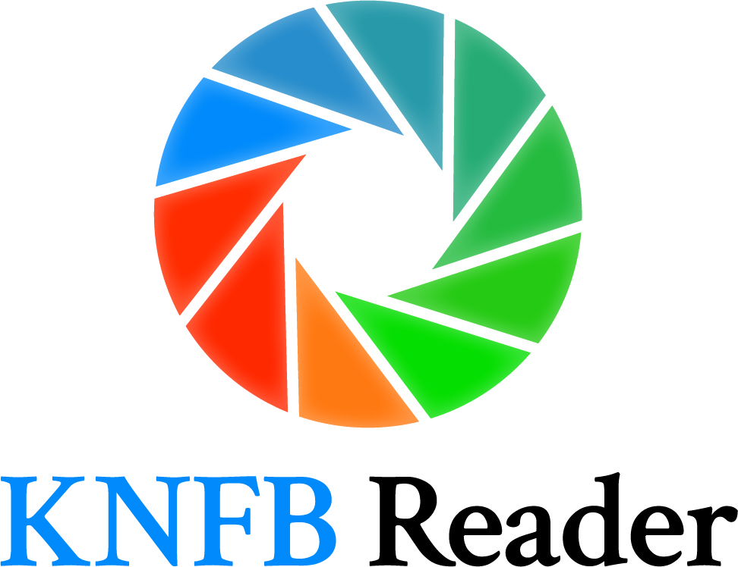
Navigating the Windows Store to Purchase KNFB Reader for Windows 10

The best experience navigating the Windows Store will be with Narrator, the nonvisual access technology built in to Windows 10, rather than other screen access solutions. While you may have success using JAWS or NVDA, Narrator is best suited to shopping in the Windows Store, particularly in the payment aspect. We recommend using Narrator instead of trying to use another screen reader when using the Windows Store to download KNFB Reader. To activate Narrator, make sure your other screen access software is turned off, and then activate Narrator by pressing Windows-Control-Enter if you have the Creator Edition of Windows 10. If you have earlier versions of Windows 10, the keystroke is Windows-Enter.
Please note: you must have Windows 10 installed on your computer in order to use KNFB Reader.
Go to the KNFB Reader page in the Windows Store. To purchase KNFB Reader, first activate the “Get the App” button, which will open the Store app on your device. At this point we recommend activating Narrator as described above. Microsoft Support has created a manual for Narrator, should you need assistance.
Your focus will typically land on the option to buy the app. Press Enter here to begin the purchase process. If you are not signed in to the Store, you will be prompted to sign in. If you already have a Microsoft account, enter your login credentials. If you do not have a Microsoft account, choose “Create an Account,” and follow the directions for creating one. After completing this step and logging in, the purchase process will continue.
If you have not already added a payment method to your Microsoft account, you will be prompted to do so. The payment entry section is the one which presents most difficulty for screen access packages. Narrator will work well throughout this particular process. Complete all of the necessary fields, and submit your payment information.
Now everything is in place, and you will be prompted to confirm your purchase. The app will download to your device, and the button previously asking you to purchase will now say “Launch.” Congratulations, you are now a proud owner of KNFB Reader! You may now return to using your usual screen reading software, or continue using Narrator. KNFB Reader will function properly with any of these.
For more information about KNFB Reader, please visit www.knfbreader.com. For support, email support@knfbreader.com, or call (347) 422-7085.

