How to Build a Menger Sponge

A Menger sponge is a fractal that sits in three-dimensional space. To visualize one, imagine starting with a cube and splitting it into twenty-seven sub-cubes, like a Rubik's cube. Remove the middle cubes from each face of the larger cube and the cube in the very middle. Now do the same thing to the twenty cubes that are remaining, dividing them up into tiny “cubelets” and removing the middle ones. When you have repeated this process infinitely many times, you are left with a Menger sponge. It has no volume but infinite surface area.
In this project, we are going to build a basic unit cube of a Menger sponge.

Materials
- To make one basic unit cube of the Menger sponge you will need six, 3x5 inch index cards.

- To make a level-one Menger sponge, you will need one-hundred and twenty, 3x5 inch index cards.

STEP 1
First, lay two index cards across one another. They should be centered and at right angles. Fold the top and bottom flaps inward, and then fold the flaps on the sides in the opposite direction. Repeat this step three times.
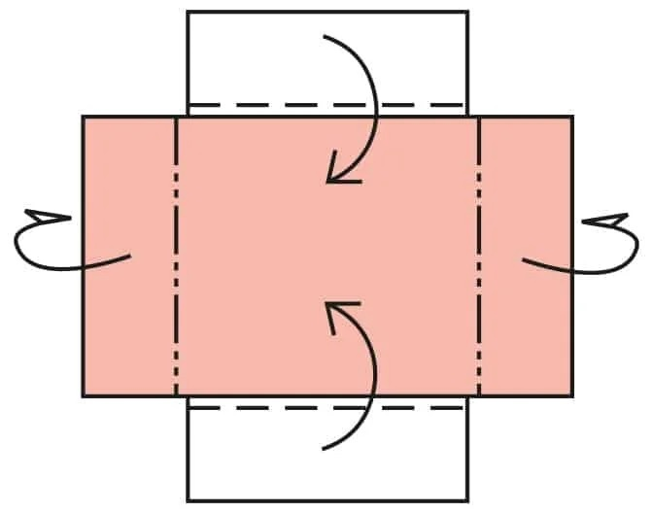
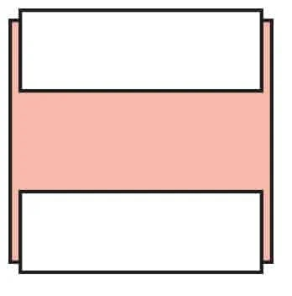

STEP 2
Separate the cards. You will have six index cards. Each card should have two flaps.

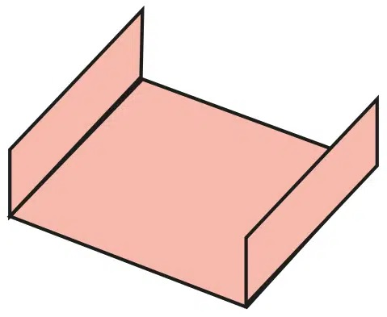

STEP 3
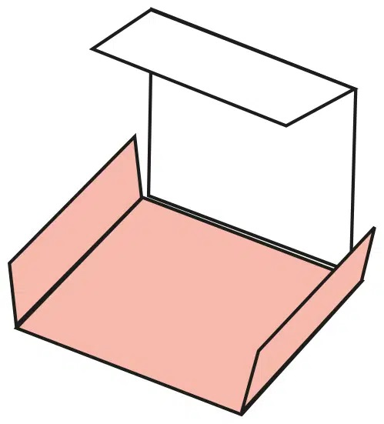
Assemble the cards so that all the flaps are on the outside, matching short edges to long edges. You can accomplish this by placing one card down on the table and putting one vertical card under each side.

STEP 4
You can then add a third card horizontally on one side, and a fourth card can then go opposite the third card horizontally. Keep adding sides until you form a complete cube. Make sure that all of the tabs are still on the outside of the cube. You now have a basic unit cube of the Menger sponge. Continue with the remaining steps to create a level-one Menger sponge.

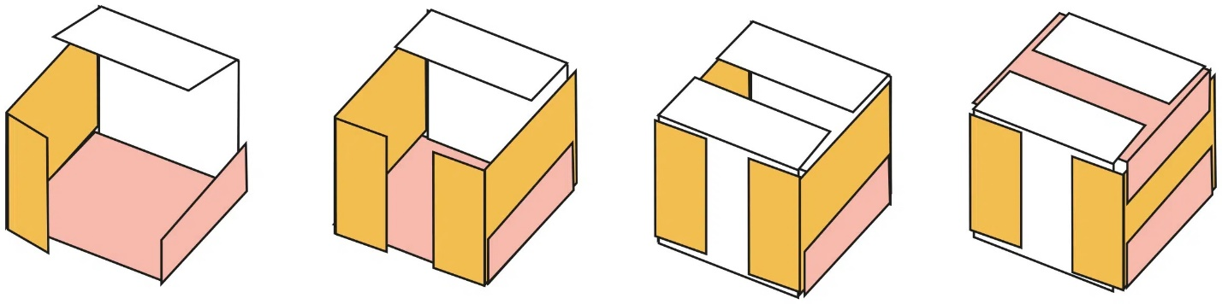

STEP 5
Join two basic unit cubes together using the tabs. Remember the tabs on each cube run either horizontally or vertically on each face. To put two together, you will need horizontal tabs on one and vertical tabs on the other to lock together the corners of the tabs. Slip a flap from one cube under the corners of two flaps on an adjacent cube. Next, slip the flaps from the other side, under the other two corners of the flaps on the second cube. Continue repeating this step to join more cubes together.
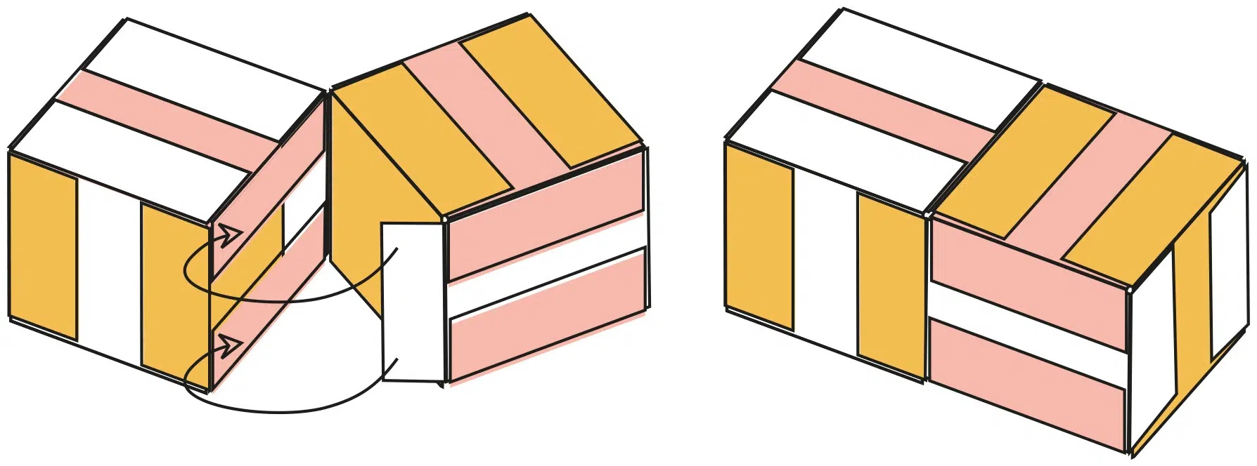

STEP 6
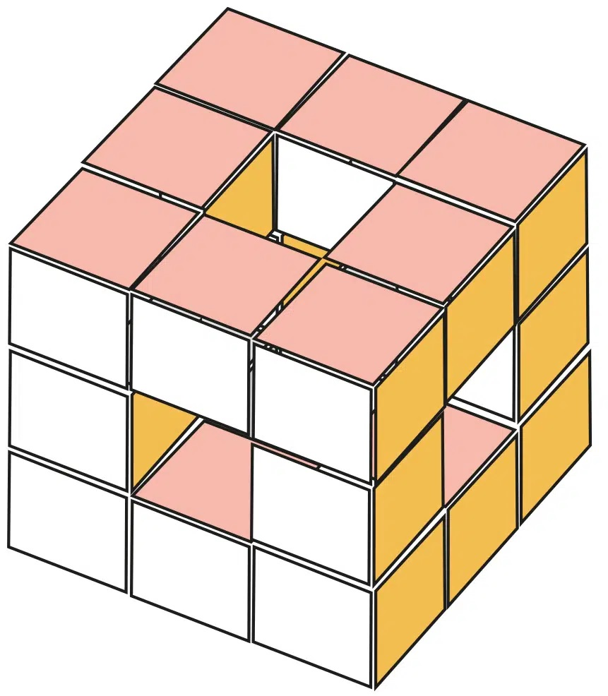
To build a level-one Menger sponge, you need to connect twenty basic unit cubes. The completed larger cube will have three columns and three rows on each side. The center space on each side will be empty.

Sources
- “Sponge Cube Instructions” The Institute for Figuring.
- “How to Build Level-One Menger Sponge?” Abakcus. https://abakcus.com/diy/how-to-build-level-one-menger-sponge/
- Lamb, Evelyn. “Build Your Own Fractal with MegaMenger!” Scientific American®. October 9, 2014. https://blogs.scientificamerican.com/roots-of-unity/build-your-own-fractal-with-megamenger/

