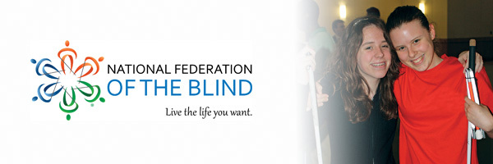

Help Us Bridge the Gap Between Blind People and Our Dreams!
I am participating in the Bay Bridge Run 10k led by the National Organization of Parents of Blind Children to raise awareness and funds for the National Federation of the Blind.
Our team is called the National Federation of the Blind Dreamers because we turn dreams into reality.
You can help cultivate respect and opportunity for blind people by contributing so we can distribute free white canes, teach kids to read Braille, advocate for educational opportunities, provide employment resources, and more.

Please visit https://nfb.org/contribute/BayBridge and put *my name* in the “in honor of” field to support me and a cause I deeply value.

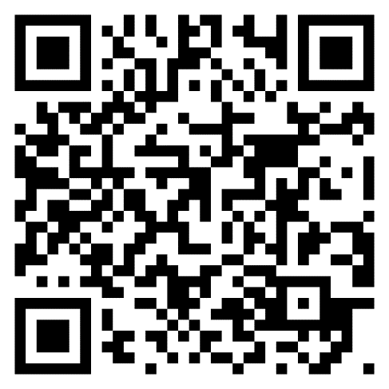

Every dollar you donate will be doubled thanks to a generous gift from HumanWare and anonymous supporters.

