Folding Tech: Using Origami and Nature to Revolutionize Technology by Karen Latchana Kenney

Introduction: Miura’s Revelation
Smoke billows on a launch pad as the engines of a rocket start. The engines, fighting against gravity's tremendous pull, have to push the rocket's heavy payload roughly 60 miles (97 km) into the air to break through Earth's atmosphere and enter space. Inside that payload is the Juno space probe, which has been in development for years. Its equipment has been packed tightly inside the tip of the long, narrow rocket, which mostly consists of fuel for the engines. After several tense minutes, the rocket leaves Earth behind and enters the darkness of space. The rocket releases its payload, and the probe begins its journey. But first, it needs to generate power. It slowly unfurls its three wing-like solar panels, which span 9 feet (2.7 m) across and 30 feet (9.1 m) long, and begins making electricity for its mission. By generating this power, the Juno probe can make its long journey to Jupiter.

Back on Earth, a swarm of tiny robots gathers at a tornado disaster site. Just minutes before, each robot was a flat piece with layers made of different materials. When exposed to heat, the layers transform and fold into new shapes as the robots automatically assemble themselves. Once they are finished, the robots begin their collective mission of photographing the wreckage and looking for survivors in areas too dangerous for humans to explore.

Incredible Folding Tech
These seemingly unrelated technologies have something very important in common. Their materials are strategically folded to fit large surfaces inside a small container or transform a flat object into a piece of technology that can move and perform tasks. Folding sounds simple-almost too simple-to be a solution to advanced engineering problems, yet it can be geometrically complex. With high mountain and deep valley creases, and points where both converge, folding creates amazingly compact, strong, and complicated structures. The use of folding in technology is a recent development inspired by the ancient Japanese art of origami, in which artists change two-dimensional paper into three-dimensional objects. Origami starts with simply just a paper square with two sides, each a different color or pattern. The only tools you use are your hands and your imagination no scissors, no glue, no tape. Nothing is added or taken away. Even within these limitations, folded paper can become almost anything, and it starts with that first fold, which changes the paper's shape completely. Now it's a triangle or rectangle. A second fold changes it again. Fold after fold brings new possibilities, and that simple paper square can take the shape of an elephant, a goldfish, or even a prickly cactus.

Folded paper creates beautiful artistic sculptures. But, there's much more to folding than the art it can become. These folds are very interesting in technological design. They have the ability to turn something very large into something very small without losing any material at all. And, if you look closely at these folds, you'll see that they are ruled by some pretty complex mathematics. As mathematicians have discovered, and continue to explore, folding follows predictable patterns. These patterns are not limited to origami art they can be found throughout the natural world.

For example, look at a leaf bud. Tightly packed inside is a much larger leaf, folded perfectly, preparing to spread out and catch the sunrays. Those rays are filled with energy that plants convert into food so they can grow and live.
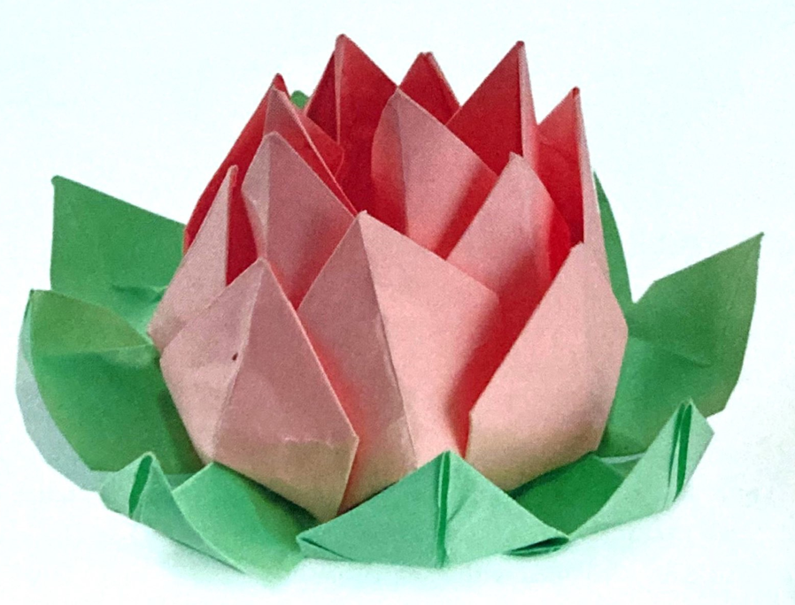
Photo of a flower leaf bud.

Solar panels also catch the sun's energy, converting it into electricity that powers machines. Both leaves and solar panels need a large surface area to capture as much sunlight as possible. Solar panels are an ideal power source for spacecraft, which have unlimited access to sunlight while in space. But, getting them into space isn't easy. Solar panels need to travel into space inside long, thin rockets. And, they need to easily expand to their full size once in space.

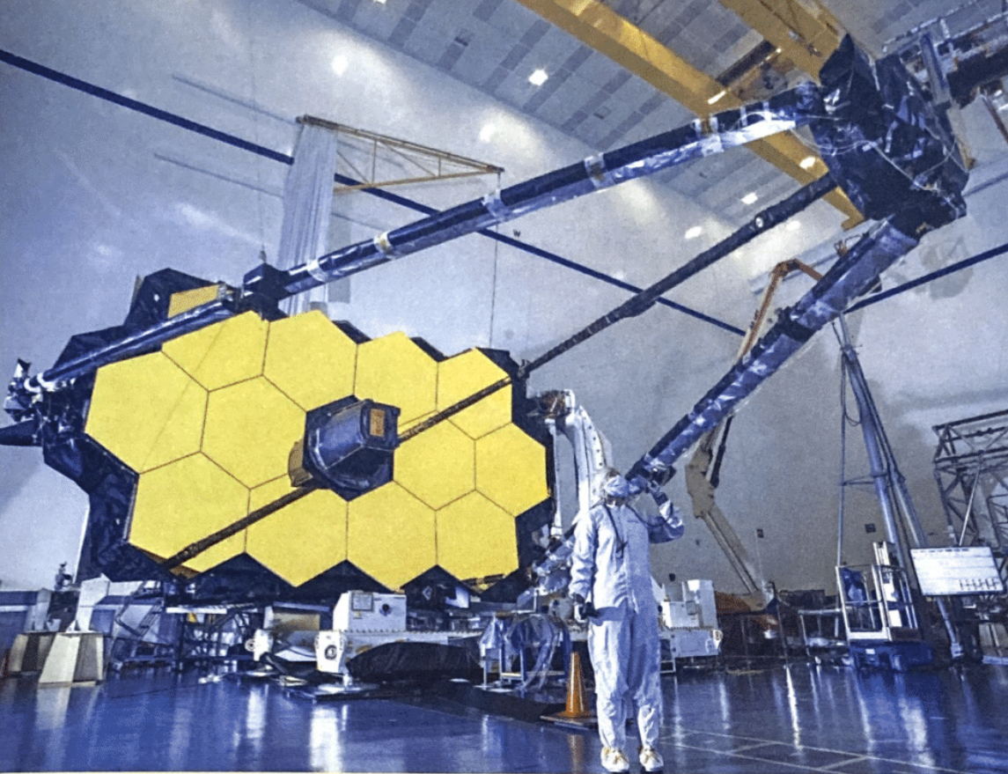
Photo of the James Webb Space Telescope. The James Webb Space Telescope, set to launch in 2021, will be the successor to the famous Hubble Space Telescope. Webb's mirror measures 21 feet (6.4 m) across, allowing it to see farther into space than the Hubble, whose mirror is only 7.9 feet (2.4 m) in diameter. Because of its size, the James Webb Space Telescope has to be folded up for launch and be able to unfold itself once in orbit.

Making the Miura-Ori
How could you fit a solar array inside a rocket? And then how could it unfold once it was in space without an astronaut to help? Japanese astrophysicist Koryo Miura, one of the founders of origami engineering, considered these questions in his research. Miura had been interested in space structures and folding since his college days. In the 1970s, he studied an ancient folding pattern he believed could be used in technological design. This pattern has mountain and valley folds that make a tessellation (repeating pattern) of identical parallelograms skewed six to ten degrees off a right angle. Using this pattern, Miura could compress a large flat surface into the compact, flat shape of one repeated parallelogram. By pulling on the corners of the paper, he could then easily expand the folded piece back to its full size. And it was easy to compress again too.

Miura called his pattern the developable double corrugation surface, which wasn't a terribly catchy name. Luckily, the British Origami Society stepped in and gave it a more memorable one. They called it the Miura-ori, Japanese for Miura's Fold. The folding pattern was perfect for maps and newspapers (the official Tokyo subway map uses Miura's Fold), but Miura had something bigger in mind. He had created Miura's Fold specifically for use in space.

In 1985, he proposed using the Miura-ori with stiff, rigid materials for solar arrays. Since this kind of technology uses materials much thicker than paper, the "folds" are made with hinges that connect stiff, flat panels to make a solar array. The Miura-ori was the perfect solution for condensing a solar array into a flat and compact shape that could fit inside a rocket. lts opening and refolding could be easily done by machinery too.

Miura's Fold made its first expedition into space with the Japanese research vessel Space Flyer Unit, which launched on March 18, 1995, and contained a number of experiments, including the Miura-ori. The vessel's solar panels were folded up tightly using the Miura-ori pattern, one stacked atop the other. Packed inside a Japanese H-lI rocket, the Space Flyer Unit launched into orbit. Then the Space Flyer Unit was released, and its experimental solar array was successfully deployed.
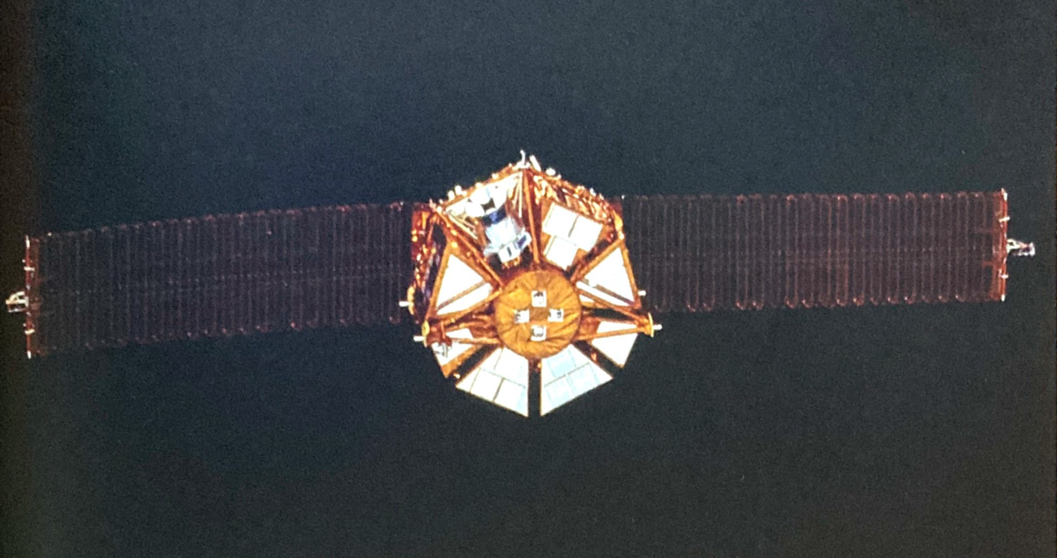
Photo of the Space Flyer Unit. In addition to the Miura-ori experiment aboard the Space Flyer Unit, the spacecraft carried Japanese fire-bellied newt eggs to observe how gravity affects their hatching process.

Miura's Fold had worked!

With that first application in the Space Flyer Unit, origami and technology fused to bring technological design into a new era. Folding technology had entered space. Where else could it go?

Chapter 1: Inside the Folds - From Paper to Robots
Folding technology didn't catch on right away in the science, mathematics, and engineering communities. After all, origami is an art form often linked with the paper cranes many people learn how to make as a kid. It was hard to take it seriously at first. But origami gradually became more popular as mathematicians, scientists, and engineers saw how its interesting patterns could create valuable technological designs. Folding an origami can solve physics problems that puzzle even the best engineers. In a surprising historical twist, something as ancient as the art of origami has evolved to inspire some of the most cutting-edge technological designs.

Origami’s Origins
Origami has a long tradition in Japan, where artists and everyday people have practiced and refined its patterns for centuries. The name comes from the Japanese words for "fold" (ori) and "paper” (gami). Paper folding began in Japan in the seventh century, when paper was a valuable and rare material. This paper was made from plant and tree pulp flattened into molds and was first brought to the country by Chinese Buddhist monks. At first, people used paper folding only for religious ceremonial purposes. This early "origami" included the shide pattern, which uses both folding and cutting to make the zigzagging streamers that hang at Shinto shrines. Shinto is the national religion of Japan, and different forms of folded paper are significant within its shrines. Folded-paper ornaments called noshi were another early form. It became the custom to place a piece of dried seafood inside the noshi and attach it onto a wedding gift. These early forms of origami had no written instructions: people taught one another how to make them.

By the seventeenth century, paper folding had moved from the shrines to the public and became a form of recreation. With the development of a papermaking industry, paper could be mass-produced and was more easily available and cheaper to buy. Japanese people began regarding paper folding as an art form. It was no longer purely a sacred practice. In 1797, the first very simple paper-folding instructions were published in the book Orikata Tehon Chushingura by publisher Yoshinoya Tamchachi of Kyoto, Japan. More people of all ages learned traditional folding patterns, including the crane, the water bomb, and different kinds of boxes.

Photo of a painting. This 1770 painting shows a woman creating a paper-folding artwork. In front of her is a pair of scissors and sheets of paper. Paper folding that allows the use of scissors to assist in making the artworks is called kirigami.

They practiced the traditional patterns they learned from their teachers or family and passed them on from one generation to the next. As a result, paper folding remained relatively the same, preserved in its traditional patterns, and few people outside of Japan knew about it.

Then, in the 1950s, origami master Akira Yoshizawa started gaining worldwide recognition for his uniquely exquisite and original origami designs. His work was exhibited in Europe and published in the Japanese magazine Asahi Graph. Soon the world knew of Yoshizawa and origami. His animal models of dogs, squirrels, wolves, horses, and more seemed imbued with life. He had mastered the basics of origami and then taken it to a new level. Known as the father of modern origami, Yoshizawa not only created new origami designs but also developed a system of dashed and dotted lines and arrows.

Sadako and Her Paper Cranes
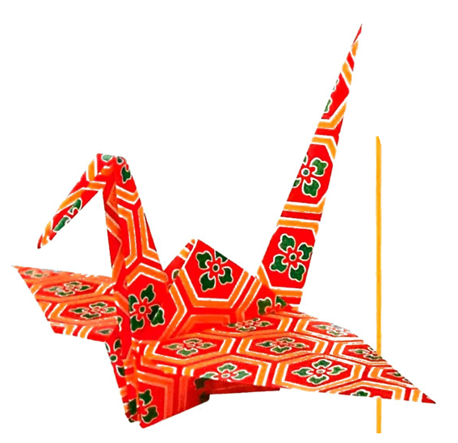
Photo of a paper crane.

Many kids around the world learn to make paper cranes, a symbol of peace and hope, as their very first piece of origami. It's an ancient Japanese pattern, but one little girl's story brought the paper crane to the world. Her name was Sadako Sasaki, and she was just two years old when she was exposed to radiation from the atomic bomb that the US dropped on Hiroshima, Japan, in 1945 before the end of World War ll (1939-1945). The bomb destroyed her city and spread toxic radiation across the land and into people's bodies. Sadako was bathed in this radiation, which caused her to develop a form of cancer called leukemia nine years later.

A Japanese belief says that if you fold one thousand paper cranes, you can be granted a wish. Sadako wished to get well, and she began folding crane after crane while she was in the hospital being treated for leukemia. Her brother believed she put her pain into every crane, never letting others know how much she was hurting inside. When Sadako died in 1955, her classmates started a campaign to build a monument in Sadako's memory. In 1958 a statue of Sadako holding a golden crane was erected in the Hiroshima Peace Memorial Park. Her story spread around the world through Austrian author Robert Jungk's book Children of the Ashes. Western efforts to ban atomic bombs used Sadako as a symbol for their movement. Sadako and her paper cranes grew to symbolize the hope for a more peaceful world. While learning about her story, nuclear bombs, and peace movements in school, children often learn how to fold origami paper cranes too. Many people send their paper cranes to Hiroshima, and the city puts them by Sadako's statue. Close to ten million cranes arrive each year from all over the world. Sadako's family has also sent her cranes to places in need of peace and healing. The first were sent to the National 9/11 Memorial and Museum, which commemorates the September 11, 2001, attacks on the World Trade Center in New York City. In 2011, when an earthquake triggered a tsunami that hit Japan and caused a meltdown at a nuclear power plant, the September 11th Families' Association and the 9/11 Tribute Center sent a gift to Japan: a welded metal origami crane made from the debris of the World Trade Center.

Photo of Akira Yoshizawa posing with some of his creations.

[Akira Yoshizawa] communicated the instructions for his designs. He first published these instructions in his 1954 book Atarashii Origami Geijutsu. This system allowed anyone to create origami. They did not need to be able to read Japanese. Western origami authors adopted Yoshizawa's language in their own books, and it became the standard way to show others how to make a piece of origami. Because of Yoshizawa's international fame and his easy-to-understand system of instructions, origami has spread throughout the world, inspiring new generations of modern origamists.

Modern Origami
With Yoshizawa's and other artists new interpretations of this ancient art, origami sculptures broke free from being the traditional flat interpretations of shapes seen in nature. Modern origami could take on round shapes and seem more lifelike. A carp fish could have scales and whiskers, just like a real one. A beetle could have tiny pincers at the tips of each leg. Realistic details like these were now possible because of the work of modern origamists, who studied the mathematical and geometrical patterns in origami's folds. Unfold an origami piece to reveal its geometry in the lines that make its folds. Within this blueprint for the finished piece are triangles, quadrangles, vertices, acute and obtuse angles, and more. Those shapes and angles follow rules to successfully create an origami piece. Studying what those rules are and how they work has led to new discoveries of what folding can create. Modern origamists are finding that almost any 3D shape imaginable can be made from paper with origami. It just takes some new tools and ways of thinking about folding Miura made his folding discovery in the 1970s and proved origami could be a practical solution to engineering problems, such as getting a solar array into space and then extending it to capture sunlight, in addition to being a beautiful art form. But, Miura was not alone in studying how origami could be used in science and engineering-many people around the world were studying the complexities of origami and its folds. In 1989 scientists, mathematicians, and origamists gathered in Ferrara, Italy, for an international scientific conference to share the ways origami, mathematics, and science intersected. This sharing of knowledge helped to rapidly advance origami science and mathematics, and the conferences became known as the Origami in Science, Mathematics, and Education (OSME) conferences. Since 1989, there have been seven OSME conferences around the world, and many of their proceedings are printed in book form. Attendees share mathematical models of origami and different applications and research into origami science-from computer tools that create origami designs to how much energy folded materials could absorb from a car crash.

One of those early origami science pioneers is former NASA engineer, physicist, and origamist Robert J. Lang. He makes some of the most complex origami sculptures in the world and is a leader in the field of computational origami, a branch of computer science that studies algorithms to solve paper-folding problems. In the early 1990s, he created a computer program called TreeMaker for designing complex origami patterns. The program turns a line drawing of a shape or figure, such as a tree or an animal, into an origami folding pattern. Each line in the drawing represents an appendage in the final sculpture: an arm or a leg, an antenna, or a jaw. It does so using a technique called circle-river packing. The program changes the stick figure into geometric shapes-circles and rivers, which assign areas of paper to be folded. Each circle in the design represents the minimum amount of paper needed to create a folded appendage. The longer the appendage, the bigger the circle. Each river in the design makes folded sections that connect appendages-such as the body segments of an insect-and the longer the section, the wider the river.

Using mathematics, his computer programs, and his skill and imagination, Lang has created origami sculptures in the shapes of a cuckoo clock, a hummingbird feeding from a trumpet blossom, a sea urchin, and many more intricate designs. He names his pieces in the style of orchestral compositions, such as Perching Cardinal, Opus 689 for an origami red cardinal perching on a branch. He uses this naming style because he believes origami is similar to music in that there are two distinct artistic forms: the "composition" (or design) and then its expression or performance (in origami, the actual fold).

"From a single composition, I and other artists can perform (or fold) that composition as individual artistic expressions, each with its own character and distinct treatment," Lang explained. "I serially number my compositions (giving them a number when I’ve made sufficient notes that I could re-create the work from my notes), and use Opus' in the same way that musicians do, as an identifier of the composition." Lang's compositions have been displayed in art museums and other exhibitions around the world, from the Museum of Modern Art in New York City to the Badisches Landes museum in Karlsruhe, Germany. He's known for his incredible artistic creations, but he's also known for his work with technological design. Engineering companies and research laboratories hire Lang to consult with them on projects involving folding. Lang can’t talk about many of the high-tech projects he's involved with, because he signed a contract preventing him from discussing them.

But, among the more public projects Lang has worked on is the Eyeglass lens, a space telescope lens he helped design in 2000. Working with the Lawrence Livermore National Laboratory, Lang developed a folding pattern for a telescope lens that could fit inside a rocket with a diameter of just 13 feet (4 m). Once unfolded, the lens would be 328 feet (100 m) in diameter, about the size of a football field, on telescope as long as Manhattan. Using an umbrella-shaped origami pattern, the laboratory created and tested a prototype of the Eyeglass lens that was 16.4 feet (5 m) across when unfolded and 5 feet (1.5 m) when folded. The prototype both folded and unfolded perfectly. Lang has also worked with German engineering company EASI, which consulted him when they wanted an algorithmic description of how to fold car airbags into a dashboard. Airbags usually sit compactly within a car's body around the seats. When there's a crash, the airbags rapidly inflate with a gas and break through the car's body to act as cushions for the passengers. Different airbags have different shapes.

Spherical, oblong, and doughnut-shaped airbags cushion in different ways. Airbag designers wanted to use computer simulations to figure out which folding patterns would work best for each shape. So, the company approached Lang. He had a computer algorithm for insect origami patterns that he thought would work for their airbag simulation program. They incorporated his algorithm into their program, and the simulation worked.

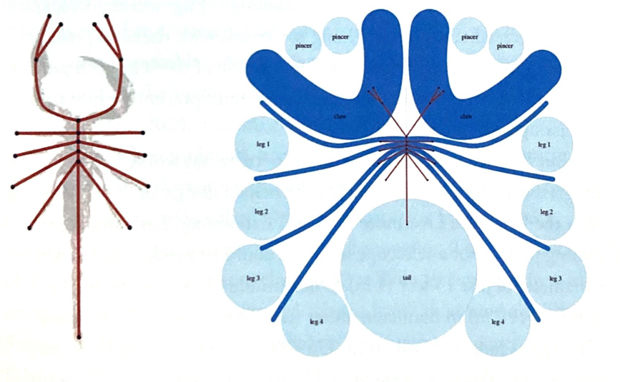
This illustration by Lang demonstrates the circle-river packing method for an origami scorpion design. His TreeMaker program transforms a stick figure (left) into the figure made of circles and "rivers" (right).

Twenty-First Century Origami Engineering
Through the early work of Miura, Lang, and many other modern origamists, the use of origami in science and technology gained momentum. What makes folding especially important in engineering is its ability to bend, stretch, and curve materials in ways that, at first glance, seem impossible, allowing large objects to fit into small spaces or transforming flat sheets into 3D shapes.
In 2012 and 2013, origami engineering got a big boost. The National Science Foundation, a federal agency that funds scientific research, awarded thirteen grants for research projects that focused on what the foundation called Origami Design for Integration of Self-assembling Systems for Engineering Innovation (ODISSEI). Each of these ODISSEI grants gave close to $2 million to cutting-edge research projects at universities and science facilities around the United States. The funded projects included origami with non-paper materials, light-activated folding, programmable folding, and folding so small that it's at a microscale.

One group of recipients came from the Massachusetts Institute of Technology (MIT). I included Professors Erik Demaine and Daniela Rus.

Simple Fuels, Enormous Possibilities: Robert Lang
When he was six years old, Robert J. Lang began what would become his lifelong relationship with origami. Working from a book, he learned to fold some simple shapes from the scrap paper lying around in his home. "And I could fold all these wonderful different patterns," Lang says. "Then, that got me interested, and I wanted to learn how to fold more and more different and diverse patterns." Eventually, Lang wanted to fold shapes of various animals but couldn't find the patterns to make the ones he wanted. So around the age of ten, he began creating his own patterns. His first design was a boat, and many more designs followed.

Lang became hooked on origami. Its limitations were especially intriguing, "It's a combination of the simplicity of the concept: a sheet of material and folding, and that's all” he says. “And folding is a pretty restrictive set of rules because you can't add material or take material away. But, in origami, the sheet you start with is the sheet you end with. So you have this very tightly restrictive set of rules, and yet there seems to be no end to the beauty, to the range of subjects we can create, to the artistic expression."

As Lang grew older, he continued folding, but it wasn't until his college classes at the California Institute of Technology that he became interested in the mathematics behind origami's folds. He realized that he could use mathematical ideas to create origami designs. What he was surprised to learn was that "the math itself of origami was also quite beautiful." Lang began his journey of exploring origami art and its mathematical aspects simultaneously, and he found that "there's this continual flow of information and inspiration between the art and the math as l learn new mathematical concepts. Those [concepts] find a home in some of the art that I'm creating or, in some cases, some of the technological things I'm trying to develop using folding. And, conversely, art and technology raise new mathematical questions to be answered, and then I can go off and explore them and try to answer them."
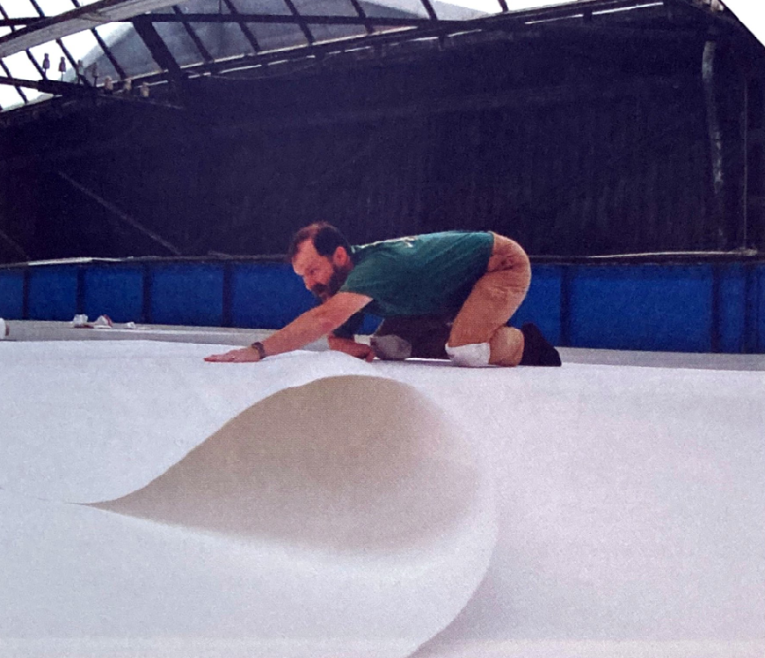
Lang folding a new piece of origami using a large piece of paper.

After getting bachelor's and master's degrees in electrical engineering, Lang went on to get his PhD in applied physics. He worked for NASA in the Jet Propulsion Laboratory (UPL) for four and a half years and then at SDL, a company in Silicon Valley, doing laser research and development for nine years. He left SDL in 2001 to become a full-time origami artist, author, and consultant. He creates origami art for collectors and advertising, teaches and lectures about origami, gives workshops on using folding in design, and consults with laboratories and companies on the applications of folding to solve technological problems. After fifty years of folding, Lang is now known worldwide as being one of the masters of origami. He has been in several documentaries about origami, including two that were shown on PBS: Between the Folds and NOVA's The Origami Revolution. He's given a TED talk on the math and artistry of origami and written many books about origami and mathematics, including Twists, Tilings, and Tessellations: Mathematical Methods for Geometric Origami. As Lang has become a master folder over the years, his designs have become more complex. One of his most complicated is of a cactus with many prickly spines. It took Lang close to seven years, off and on, to fold this masterpiece, which he calls Cactus, Opus 680. Origami is a way of life for Lang, and he couldn't imagine it not being so. As he continues to create his origami designs and compositions, Lang says, “The more l explore origami, the more potential I find, the more creating new expressions of art."
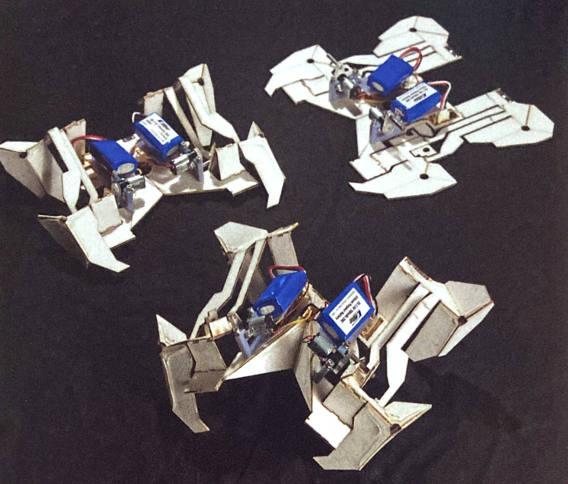
Photo of a self-folding robot transitions from one shape to another as it prepares to walk.

They had been working for a few years to develop a simple robot that could change its shape by folding itself on command. Along with a team of researchers at Harvard University, their work resulted in a 3D-printable robot made of five layers of materials. The middle layer is copper etched into lines that conduct electricity. This is sandwiched between two layers of paper that give the robot structure. Then two motors attach to the top of the robot. Finally, the copper and paper layers are sandwiched between a polymer that shrinks when it gets hot, just as a Shrinky Dink does.

The flat robot is put through a laser-cutting machine that creates the folding patterns. When the polymer heats up and shrinks along the lines drawn by the laser, the robot folds itself into a shape with four legs, each pair controlled by a motor. It can then walk away on its own. Demaine, Rus, and their team hope to make even bigger versions of these kinds of flat-packed self-folding robots and deploy them in harsh environments, such as on the surface of Mars or on battlefield-places where people could be hurt or killed but where a robot would fare just fine. Origami has led to many exciting technological possibilities, including these self-folding robots, and will lead to many more. The ODISSEI grant helped bring origami engineering into the technological mainstream. Many scientists and engineers are beginning to discover how folding can help solve the problems of sending large technology into outer space and tiny technology into human bodies, as well as many frontiers in between.

